Urban Greenery Coverage in the Greater Malé Area
1. Introduction
The concentration of buildings, roads, and other artificial surfaces causes cities to absorb and retain more heat than surrounding rural areas, a phenomenon known as the Urban Heat Island (UHI) effect. This effect is particularly pronounced in dense urban centers like Malé. This report analyzes the current state of greenery coverage in Malé and Hulhumalé, using scientific literature to contextualize the impact of this coverage on urban temperatures and human thermal comfort.
2. Analysis of Local Greenery Coverage
2.1 Methodology The greenery coverage was calculated using a multi-step analysis of satellite imagery. The process involved vectorizing satellite footage into colored polygons, deleting non-land areas like the sea, and manually correcting the color of polygons that appeared green but were not vegetation (e.g., green rooftops). The final percentage was derived by taking a full pixel count of green pixels against the total land area pixels.
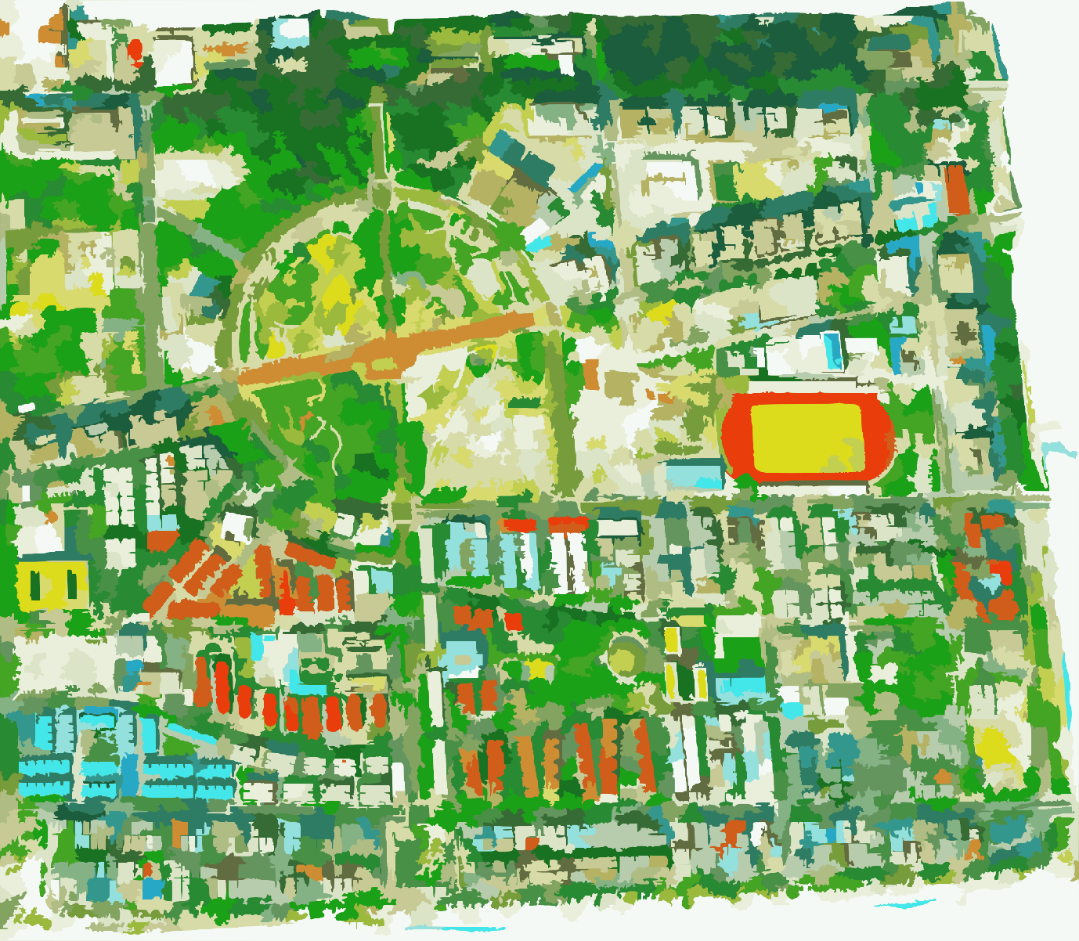
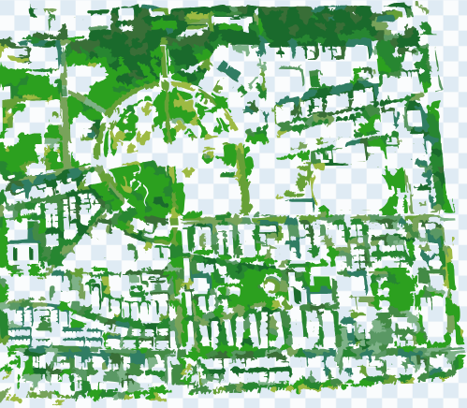
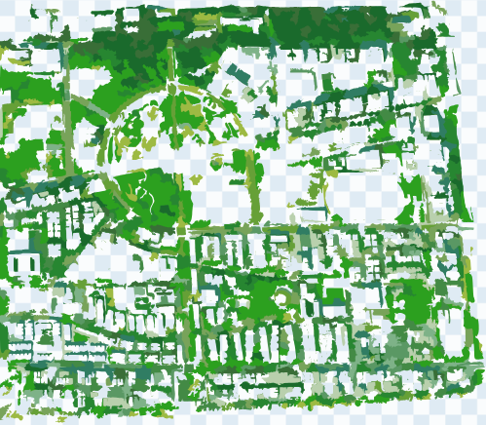
2.2 Findings
- Hulhumalé: For Hulhumalé Phase 1 as a whole, different selections of borderline green shades gives between 21.8% to 31.8%, with the likeliest numbers being around 25-28%.
- For the primarily residential northern half of Hulhumale’ Phase 1 (north of Orchid Maa Hingun), different selections of borderline green pixels give percentages between 30.1% to 45.2%, with the likeliest numbers being around the 35-40% mark. This is the only residential area of Male’ City which meets the desired percent of urban greenery coverage for positive liveability impacts.
- Malé: Greenery coverage in Malé is significantly smaller and is mostly concentrated in a few specific locations, namely Sultan Park, Lonuziyaaraiy Park, and along the streets of Fareedhee Magu and Ameer Ahmed Magu. Different selections of borderline green pixels give percentages between 12.5% to 16.5% with likelier numbers toward the low end.
3. Context and Impact of Canopy Cover: A Review of Scientific Literature
3.1 The 40% Threshold for Optimal Cooling Scientific research indicates that the cooling benefits from trees are not uniform across all levels of coverage. A 2019 study found that the relationship is nonlinear, with the greatest cooling effects occurring when tree canopy cover exceeds 40%.
3.2 Quantifiable Cooling Effects Multiple studies have measured the direct impact of greenery on urban temperatures:
- A linear cooling effect has been observed, with an approximate air temperature reduction of 1.4 °C for every 10 percentage point increase in tree cover. Based on this model, Hulhumalé Phase 1's 20-30% coverage provides an estimated cooling of 2.8 °C to 4.2 °C. For the northern part of Phase 1, 35-40% with these calculations would provide an estimated cooling of 4.9 °C to 5.6 °C.
- In streets with high-percentage tree cover, afternoon air temperatures can be reduced by up to 3.3 °C, and mean radiant temperatures by a remarkable 13.9 °C, compared to similar streets with no shade.
- Even artificial shading is effective. Umbrellas can reduce radiant heat exposure by 15–20% , and building-integrated shades or pergolas can reduce local temperatures by up to 2.1–3°C.
3.3 Human Thermal Comfort and Health The benefits of greenery extend beyond simple temperature reduction to overall well-being:
- Planting dense canopy trees was found to reduce the mean radiant temperature (TMRT) by 35% and improve the Physiological Equivalent Temperature (PET), a measure of thermal comfort, by 25%.
- The UHI effect exacerbates heatwaves, which are associated with increased mortality. Research from Sydney found that over 90% of heatwave days would not have breached official thresholds if there were no UHI effect. The study concluded that widespread tree planting can reduce urban heat and could help offset increases in heat-attributable deaths as the climate warms.
4. Conclusion
Hulhumalé's green spaces, with 20-30% tree canopy cover, provide a significant and measurable cooling effect that mitigates urban heat. However, scientific literature clearly indicates that a target of over 40% canopy cover is necessary to achieve the most effective reduction of the Urban Heat Island effect. This percentage is found in the northern part of Hulhumale Phase 1. In contrast, Malé's minimal greenery coverage leaves it highly susceptible to the negative impacts of urban overheating. In future research, we will aim to measure ambient temperatures in various locations of Male’ and Hulhumale’ to identify whether recorded numbers match these estimates. We also encourage other organizations with more resources to do a more precise analysis of greenery coverage of Male’ City, understanding that our methodology is a relatively crude approach and gives a wide range of estimates which is more useful in illustrating an issue than in providing a precise scientific estimate.
Bibliography
Battista, G., De Lieto Vollaro, E., Evangelisti, L., & De Lieto Vollaro, R. (2022). Urban Overheating Mitigation Strategies Opportunities: A Case Study of a Square in Rome (Italy).
Sustainability.
Chaston, T., Broome, R., Cooper, N., Duck, G., Geromboux, C., Guo, Y., Ji, F., Perkins-Kirkpatrick, S., Zhang, Y., Dissanayake, G., Morgan, G., & Hanigan, I. (2022). Mortality Burden of Heatwaves in Sydney, Australia Is Exacerbated by the Urban Heat Island and Climate Change: Can Tree Cover Help Mitigate the Health Impacts?.
Atmosphere.
Huang, Z., Wu, C., Teng, M., & Lin, Y. (2020). Impacts of Tree Canopy Cover on Microclimate and Human Thermal Comfort in a Shallow Street Canyon in Wuhan, China.
Atmosphere.
Lee, I., Voogt, J., & Gillespie, T. (2018). Analysis and Comparison of Shading Strategies to Increase Human Thermal Comfort in Urban Areas.
Atmosphere, 9, 91.
Middel, A., Chhetri, N., & Quay, R. (2015). Urban forestry and cool roofs: Assessment of heat mitigation strategies in Phoenix residential neighborhoods.
Urban Forestry & Urban Greening, 14, 178-186.
Zaki, S., Toh, H., Yakub, F., Saudi, A., Ardila-Rey, J., & Muhammad-Sukki, F. (2020). Effects of Roadside Trees and Road Orientation on Thermal Environment in a Tropical City.
Sustainability, 12, 1053.
Ziter, C., Pedersen, E., Kucharik, C., & Turner, M. (2019). Scale-dependent interactions between tree canopy cover and impervious surfaces reduce daytime urban heat during summer.
Proceedings of the National Academy of Sciences, 116, 7575 - 7580.

